ONEWAY Memory BY DAW
/STATISTICS DESCRIPTIVES HOMOGENEITY WELCH
/PLOT MEANS
/MISSING ANALYSIS.

Oneway

Notes
Output Created |  | 05-May-2019 23:24:20
Comments
Input | Active Dataset | DataSet0
Input | Filter | <none>
Input | Weight | <none>
Input | Split File | <none>
Input | N of Rows in Working Data File | 30
Missing Value Handling | Definition of Missing | User-defined missing values are treated as missing.
Missing Value Handling | Cases Used | Statistics for each analysis are based on cases with no missing data for any variable in the analysis.
Syntax |  | ONEWAY Memory BY DAW  /STATISTICS DESCRIPTIVES HOMOGENEITY WELCH  /PLOT MEANS  /MISSING ANALYSIS.
Resources | Processor Time | 00 00:00:00.172
Resources | Elapsed Time | 00 00:00:00.165

[DataSet0]

Descriptives
 | N | Mean | Std. Deviation | Std. Error | 95% Confidence Interval for Mean
 |  |  |  |  | Lower Bound | Upper Bound
1-3 days a week | 12 | 113.3125 | 38.39687 | 11.08422 | 88.9163 | 137.7087
3-5 days a week | 5 | 73.2400 | 16.46949 | 7.36538 | 52.7904 | 93.6896
5-7 days a week | 13 | 85.0877 | 25.67129 | 7.11994 | 69.5747 | 100.6007
Total | 30 | 94.4030 | 33.66618 | 6.14658 | 81.8318 | 106.9742

Descriptives
 | Minimum | Maximum
1-3 days a week | 64.50 | 166.00
3-5 days a week | 48.00 | 92.25
5-7 days a week | 55.50 | 138.00
Total | 48.00 | 166.00

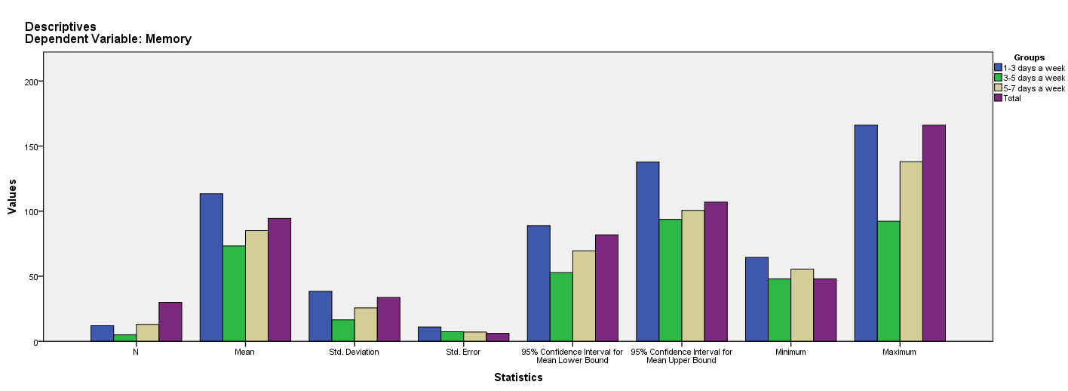

Test of Homogeneity of Variances
Memory
Levene Statistic | df1 | df2 | Sig.
6.060 | 2 | 27 | .007

ANOVA
Memory
 | Sum of Squares | df | Mean Square | F | Sig.
Between Groups | 7658.268 | 2 | 3829.134 | 4.101 | .028
Within Groups | 25210.677 | 27 | 933.729
Total | 32868.945 | 29

Robust Tests of Equality of Means
Memory
 | Statisticª | df1 | df2 | Sig.
Welch | 4.339 | 2 | 14.834 | .033
a. Asymptotically F distributed.

Means Plots

